|  |  |
| --- | --- |
| linear IPS | Year 12 Methods  TEST 2  Monday 8 April 2019  TIME: 45 minutes working  One page of notes allowed  **Calculator Assumed**  43 marks 5 Questions |

Name: _______________________________ Teacher: ___________________________

**Note: All part questions worth more than 2 marks require working to obtain full marks.**

**Question 1 (7 marks)**

1. Differentiate $\frac{x}{e^{x}}$ and simplify your answer if necessary. (3 marks)
2. Using your result from (a) above and **without the use** of a Classpad, show how to determine the definite integral $\int_{0}^{1}{\frac{1-x}{{2e}^{x}} dx}$. (4 marks)

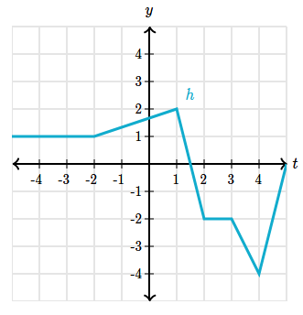**Question 2 (8 marks)**

The graph of $h(x)$ is shown on the right.

1. Evaluate the following definite integrals
2. $\int_{-2}^{2 }{ h\left(x\right) dx}$ (2 marks)
3. $\int_{-2}^{2}{h^{'}\left(x\right) dx}$ (2 marks)
4. Determine the area bounded by the graph of $h^{'}(x)$ and the $x$ axis between $x=-2$ and

$x=2$. Justify your answer. (4 marks)

**Question 3 (10 marks)**

Let $F(x)= \int_{0}^{x}{f\left(t\right) dt,}$ where $f(t)$ in the picture on the right.

1. 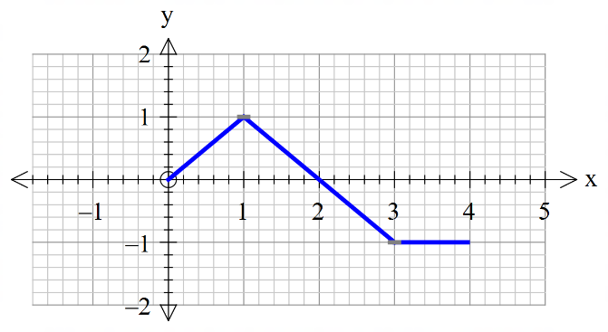Determine the value of $x$ for a maximum of $F\left(x\right).$ Briefly explain your reasons. (3 marks)

1. Evaluate $F\left(3\right)$. (2 marks)
2. Determine the value of $x$ for a maximum of $F'\left(x\right).$ Briefly explain your reasons. (3 marks)
3. Evaluate $F^{'}\left(4\right)$. (2 marks)

**Question 4 (10 marks)**

A new substance labelled **XX** is found to decay by the rule , where  equals the mass of the substance in kilograms at time  minutes.

Determine the following:

1. the initial mass of **XX**. (1 mark)
2. the time taken for half of the mass to decay away to the nearest minute. (3 marks)

The radiation is safe for humans when the rate of decay is less than 100 kg per minute.

1. Determine after how long the radiation will become safe for humans. (3 marks)

A different substance **YY** has a rate of decay given by , where  equals the mass of the substance in kilograms at time  minutes.

1. Determine the total change in the mass from  to minutes. (3 marks)

**Question 5 (8 marks)**

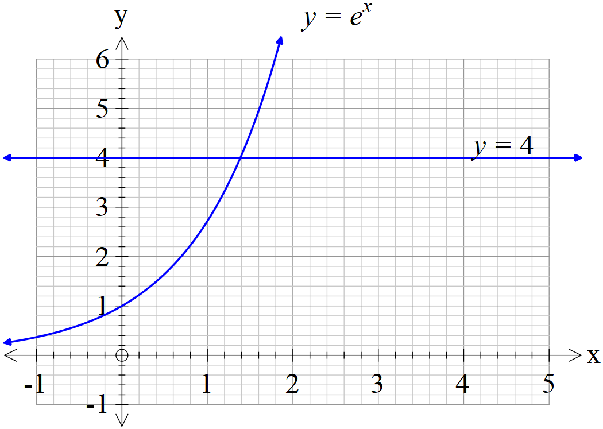

1. Using the solve facility on your Classpad, determine to two decimal places the $x$ value where the two graphs above intersect. (2 marks)
2. Determine to two decimal places the area bounded by  and the $y$- axis.

(3 marks)

1. Let  where , determine the value of , to two decimal places, such that the area between  and the $y$-axis equals 1.5 sq units. (3 marks)

Supplementary Page

Question Number: _____________

Supplementary Page

Question Number: _____________